3.2 Assignment
Trent Jorgensen
ECPI University
SDC385
Instructor: Dr. Iyinbor
March 16, 2026
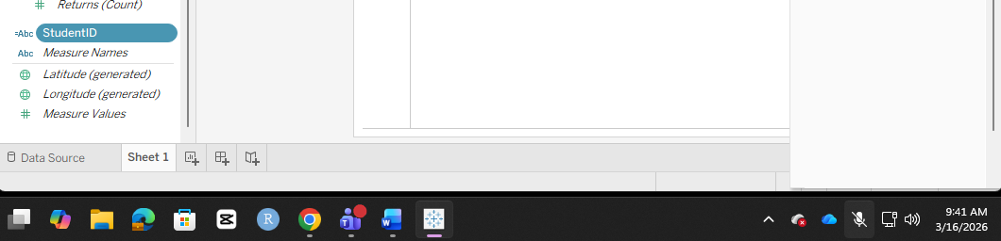
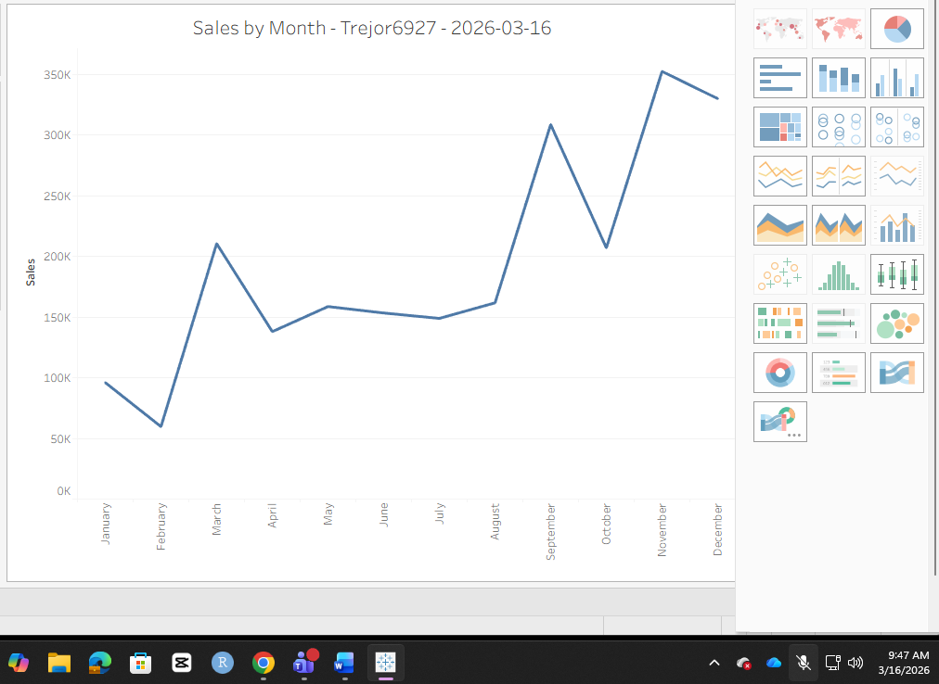
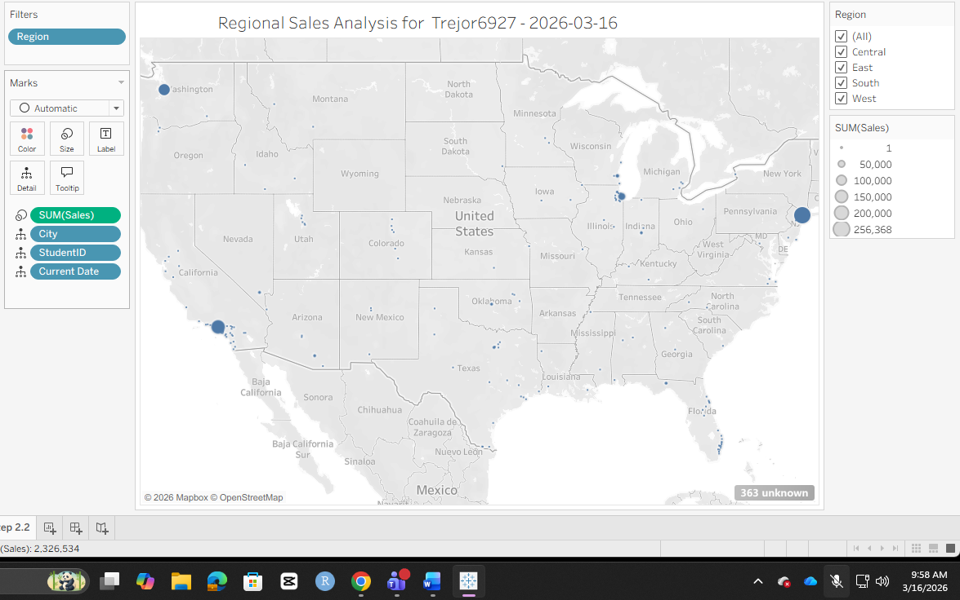
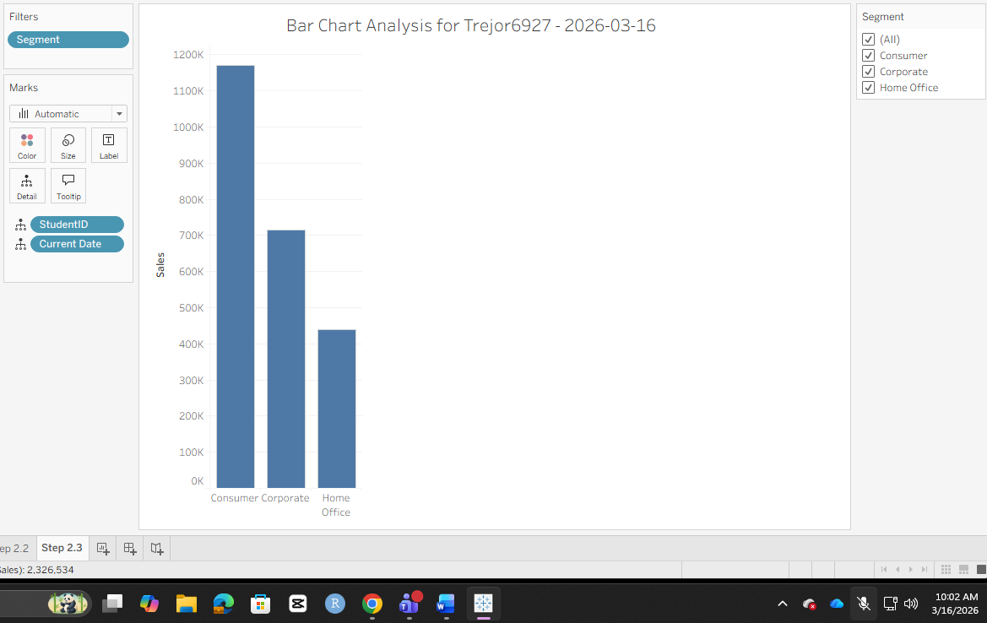
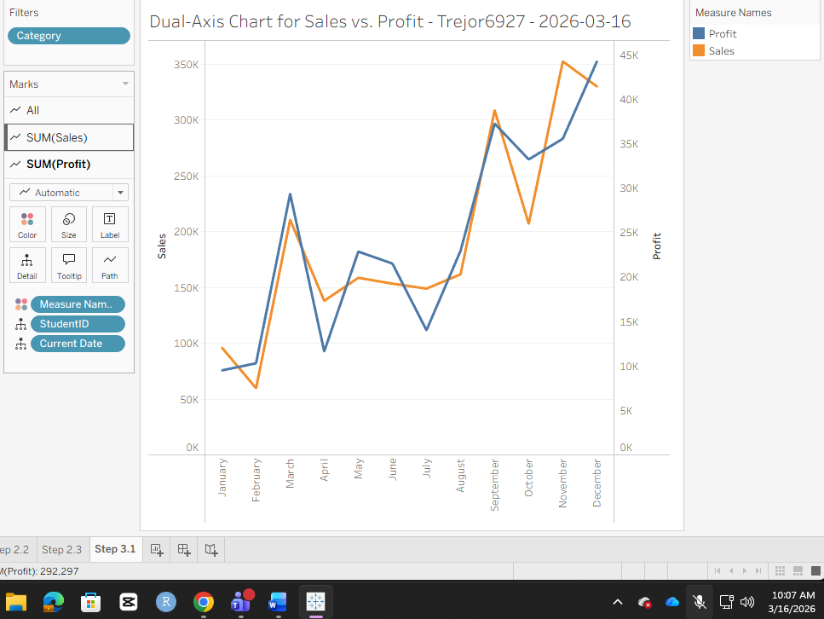
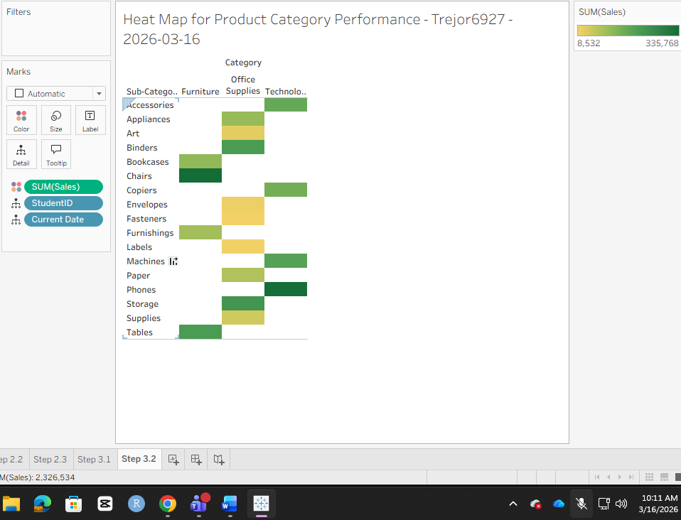
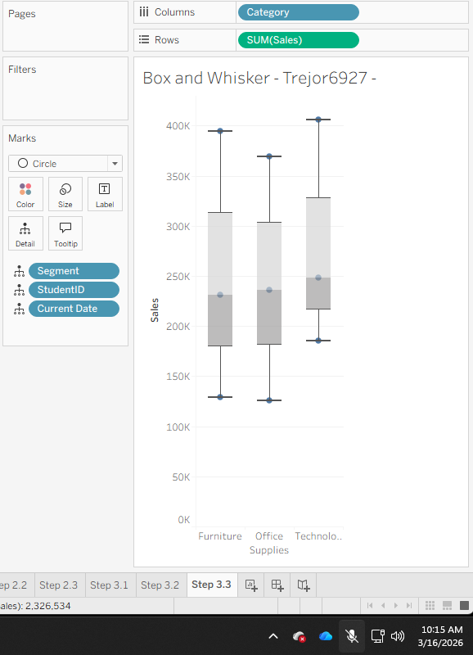
- How does a box and whisker plot display the central tendency and variability of a dataset?
The box and whisker chart displays the highs and the lows. What makes this chart useful is that it focuses on what the true Median is. So, in the furniture chart your High is about 400k and your Low is about 125k. You would think that your average would be closer to 262.5k, when really it is lower being at about 231k.

- What is the difference between a measure and a dimension in Tableau?

The dimension filter dives deeper into the data set. If I were to set the data to the Attribute filter, it would combine all the data creating an overall generalization of the high, low, and average data marks. With the dimension filter, it separates the categories and displays that department’s sales. This filter would be extremely useful because it would show which department is making the most money and which department needs improvement.

- How can you ensure a field is treated uniquely in a view without aggregating it in Tableau?

You can set the table into marks or filter sections. From there, you can display the type of filters that you want to show to the client. This will help ensure that the marks split by their field.

